Suits TV Show Viewership Report

Jan Frąckowiak

2024-09-07

Note: to get the PDF, Jupyter outputs run quarto render suits_report_mod.qmd in terminal.

## Introduction

Suits is a legal drama television series that first aired on USA Network on June 23, 2011. Created by *Aaron Korsh*, the show follows *Mike Ross*, a college dropout with a photographic memory, who starts working as an associate at a top New York law firm despite not having a law degree. With intense legal battles, power plays, and personal struggles, Suits became one of USA Network’s most popular series, running for nine seasons and concluding in 2019.

## Suits Logo



Suits Logo

## Viewership Over Time

Below is a line graph representing the last episode viewership per season.

# Import necessary libraries  
import matplotlib.pyplot as plt  
import numpy as np  
  
## Viewership data  
seasons = list(range(1, 10))  
viewership = [3.47, 3.20, 2.40, 1.55, 1.71, 1.13, 1.07, 0.74, 0.86]  
  
## Plotting the graph for Viewership per Season  
plt.figure(figsize=(10, 6))  
plt.plot(seasons, viewership, marker='o', color='b', linestyle='--')  
plt.title('Suits - Last Episode Viewership per Season (in millions)')  
plt.xlabel('Season')  
plt.ylabel('Viewership (in millions)')  
plt.xticks(seasons)  
plt.grid(True)  
plt.show()

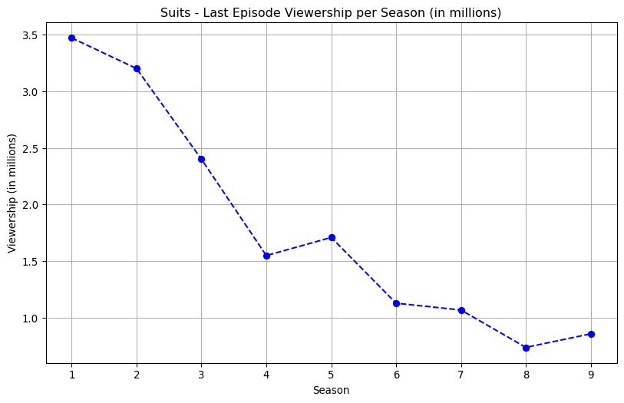

## Percentage Change in Viewership

To visualize how the lasting viewership changed between seasons, here is a bar graph representing the percentage change in viewership from one season to the next.

# Import necessary libraries  
import numpy as np  
  
# Calculating the percentage changes between seasons  
changes = np.diff(viewership) / viewership[:-1] * 100  
  
# Plotting the changes  
plt.figure(figsize=(10, 6))  
plt.bar(seasons[1:], changes, color='r')  
plt.title('Percentage Change in Last Episode Viewership Between Seasons')  
plt.xlabel('Season')  
plt.ylabel('Percentage Change (%)')  
plt.xticks(seasons[1:])  
plt.grid(True)  
plt.show()

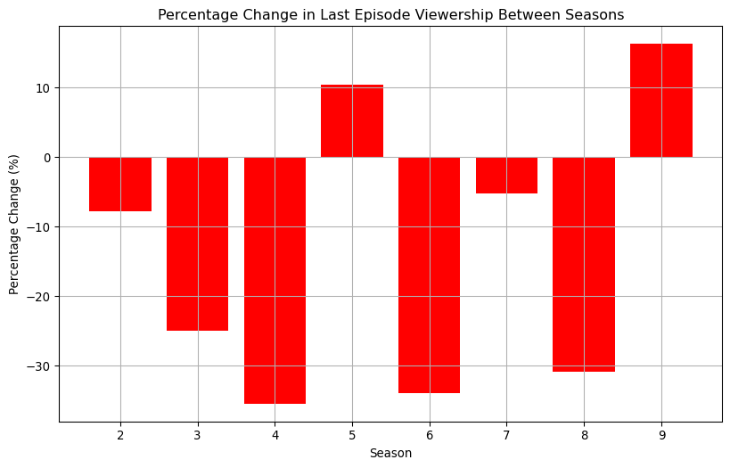

## Analysis of Viewership Trends

Over the show’s nine seasons, Suits experienced significant fluctuations in its lasting (last episode) viewership numbers.

In Season 1, the show ended with of 3.47 million viewers. However, by Season 2, the viewership dropped by -7.78%, ending with 3.2 million. Except for Season 4 and Season 9, Suits experienced drops in viewership of the last episodes.